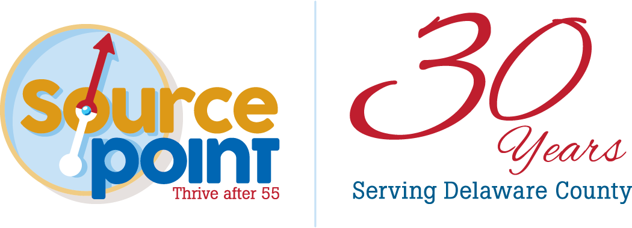
PRESS RELEASE
Contact: Alison Yeager
Director of Communications & Development
740-363-6677 | alison@MySourcePoint.org
800 Cheshire Road
Delaware, Ohio 43015

This release is available on the SourcePoint website at MySourcePoint.org/press.

FOR IMMEDIATE RELEASE: Nov. 9, 2022
Delaware County Senior Services Levy Passes

DELAWARE COUNTY—Delaware County voters approved a renewal of the Senior Services Levy at 1.3 mills with an addition of 0.1 mill. Late Tuesday night, unofficial Board of Elections data showed the levy had passed with 69% of the vote in favor of the levy.

“We are so grateful to community members for their continued support of the levy,” said Fara Waugh, CEO of SourcePoint. “This means we can sustain the vital aging services we have put in place for the last 30 years and maintain support of the rapidly growing older population in Delaware County.”

The property tax levy provides over 80% of the nonprofit organization’s funding, which supports in-home care services, such as care management, Meals on Wheels, personal care, emergency response systems, adult day services, and medical transportation. Funds also enable SourcePoint to provide health and wellness programs, nutrition programs, insurance education, caregiver support, volunteer opportunities, and more.

The current levy expires at the end of 2023, and the newly approved levy will provide funding from 2024 through 2028. The new total costs will be $35.10 per $100,000 of assessed property value, which is a modest increase of $3.50 per year.

SourcePoint is a nonprofit 501(c)(3) organization that provides professional expertise, services, and programs for Delaware County adults who want to thrive after 55 and family caregivers. Services and programs are supported in part by the local senior services levy, corporate and private donations, grants, the Central Ohio Area Agency on Aging, and United Way of Delaware County.

