PRESS RELEASE
Contact: Alison Yeager
Director of Communications & Development
740-363-6677 | alison@MySourcePoint.org
800 Cheshire Road
Delaware, Ohio 43015

This release is available on the SourcePoint website at MySourcePoint.org/press.

FOR IMMEDIATE RELEASE: Jan. 3, 2023
SourcePoint Welcomes Four New Board Members

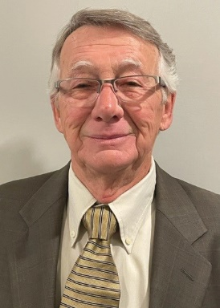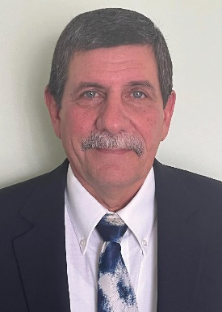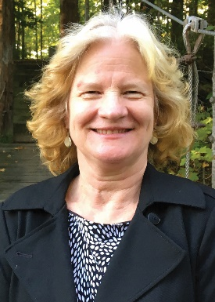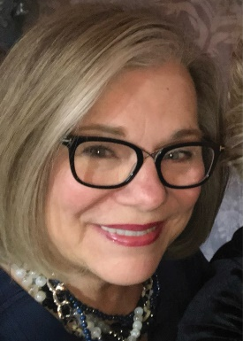
Pictured, left to right: Bill Brown, Ron Fantozzi, Annie Horstman, and Cheri Thompson.

DELAWARE COUNTY—SourcePoint announces the appointment of four new members to its board of directors, as well as the full slate of officers and board members for 2023. Joining the board of directors are William Brown, Ron Fantozzi, Anna Horstman, and Cheri Thompson.

William (Bill) Brown is a retired quality assurance executive who previously served on SourcePoint’s board of directors from 2015 through 2018. Prior to that, Brown served on the board of Senior Citizens Inc. from 2011 through 2014. He brings extensive knowledge of the history of the nonprofit organization, as well as Delaware County’s aging population. A Delaware resident, Brown has volunteered for several years as a special projects committee member at the Central Ohio Area Agency on Aging, as well as a fitness center attendant and golf league coordinator at SourcePoint.

Ron Fantozzi, a Columbus resident, recently retired from Trane Technologies and has extensive volunteer experience. For over 30 years, he has volunteered at local organizations, including the Jaycees, Kenton High School, SourcePoint, and the Special Olympics. Fantozzi also serves on the board of directors for his Homeowners Association and was a trustee of the Alum Creek Sailing Association for three years.

Anna (Annie) Horstman is a physician who moved to Delaware County from Putnam County upon retirement. In Putnam County, she served on the health board and library board. Since moving to Delaware, Horstman has been an active participant in SourcePoint’s community programs. From 2020 through 2022, she served on the Delaware-Morrow Mental Health and Recovery Services Board.

Cheri Thompson recently retired from her position as executive director of global technology from JPMorgan Chase. She has extensive volunteer experience with organizations like the Foster Care Ministry, Friends of the Delaware County District Library, and Susan G. Komen Columbus Race for the Cure Survivor Tribute. Thompson, a Delaware resident, is an active participant in SourcePoint’s community programs.

The full 2023 board includes 19 individuals: President Gretchen Roberts, Vice President Alice Frazier, Secretary Pamela Foster, Treasurer Dennis Mowrey, Sustaining Director Roger Van Sickle, Randy Bournique, William Brown, Adrienne Corbett, Carlos Crawford, Karen Crosman, Ron Fantozzi, Jack Fette, Liz Gitter, Anna Horstman, Wren Kruse, Joann Richards, Jane Taylor, Cheri Thompson, and Michael Tucker.

SourcePoint’s board of directors is responsible for establishing the mission and ensuring that the organization continues to fulfill that mission with legal and ethical integrity. The board determines the strategic direction and provides financial oversight of the nonprofit organization. The board employs a chief executive officer to supervise staff, implement policy, and oversee day-to-day operations.

SourcePoint is a nonprofit 501(c)(3) organization that provides professional expertise, services, and programs for Delaware County adults who want to thrive after 55, as well as family caregivers. Services and programs are supported by the local senior services levy, private and corporate donations, grants, and the Central Ohio Area Agency on Aging.

