More Than Just a Meal:
How Delivering Meals on Wheels Provides More Than Nutrition to Our Clients

As you may have seen on the sides of our delivery vans or in our publications, SourcePoint’s Meals on Wheels (MOW) program is proud to offer “More Than Just a Meal” to our clients. In addition to nutritious foods for clients and their pets, the program provides a wellness check and much needed social interaction to older adults in Delaware County.

Social Isolation
Social isolation is common for the clients we serve. Many live alone and are homebound, having limited access to the outside world. Social isolation increases health risks such as heart disease, weakened immune system, cognitive decline, depression/anxiety, dementia, overweight, and diabetes.

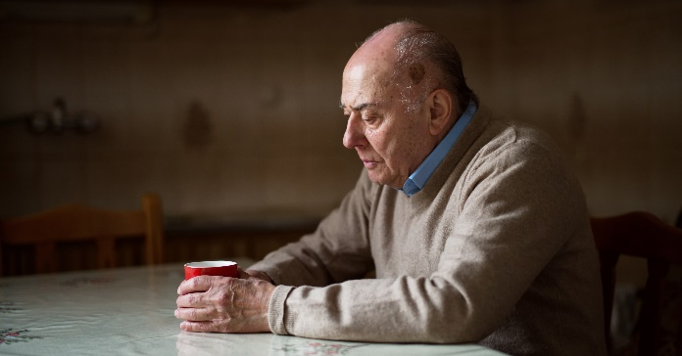

Driver Impact
When MOW drivers deliver meals to clients, they give the client someone to talk to – even if briefly – and reduce the level of social isolation which the client is facing. The smiling face of a delivery driver has the power to change a client’s day for the better. In a survey conducted in July 2023, almost half of all Meals on Wheels clients in our program reported that their delivery driver is the only person they see or talk to most days. These short interactions help reduce social isolation and the health risks that come with it.
Wellness checks
With the SourcePoint nutrition department being the main point of contact for many individuals around the county, providing a wellness check is hugely impactful to client health. Using the Mobile Meals app on the delivery tablet, drivers can report changes of condition they notice in the clients’ health. Perhaps a client has come down with a cough or mentioned that they feel confused lately. These notes can go into the change of condition notes. This information travels in real time back to the nutrition office and we forward it along to the client’s care consultant. The care consultant then follows up appropriately. This whole process can take as little as a couple of minutes!
In some instances, drivers have found clients in crisis during their delivery route. When a client who has fallen or is having some other medical emergency is found, the delivery driver must call emergency responders. In these cases, the impact of the driver and the wellness check can be lifesaving.
When a client is not home for delivery, the wellness check is not possible, and meals cannot be delivered. Using the Mobile Meals app, drivers must report that the client was a No-Show. Upon receiving this information, the Nutrition Department at SourcePoint immediately begins follow-up with the client and the client’s emergency contacts as appropriate until contact has been made. This allows us to verify the wellbeing of the client.

Why wellness checks matter
As mentioned above, when a wellness check cannot be conducted, meals cannot be left for clients. While clients may leave notes outside their doors requesting meals be left on doorknobs or in coolers, leaving meals is forbidden by SourcePoint policy. Leaving meals violates food safety best practices and does not allow for a wellness check. But why are wellness checks so important?
One reason is that these checks are required by our Title 3 funding requirements. By skipping the important step of providing a wellness check, our funding is put in jeopardy.
The second reason checks matter, is related to client health. Drivers have found clients who have fallen in their home and are unable to get up. Drivers have also come upon clients having cardiovascular and diabetic events. In rare cases, drivers have discovered clients who are deceased. In these situations, if the drivers had simply left the meals on the doorknob, marked the meals as “delivered” in the tablet app, and moved on to the next delivery, the status of the client would have remained unknown, and no follow-up would be made.
Below are some real-life examples of incidents which have occurred in the MOW program at SourcePoint. This list includes both wellness checks that have gone right and gone wrong:
- Gone Wrong
  - Meals on Wheels driver thought they heard the client in the home, so they left the meals on the doorknob. Two days later a different driver came for their delivery and found those meals still hanging on the doorknob. After follow up was done, it was discovered that the client was deceased in the home.
  - The driver left meals on a doorknob in an apartment building for several days in a row. Later, the client was found in her home in a diabetic coma and passed away a few days later. Since the office was never alerted that the client was not answering the door, the follow-up which could have saved a life never took place.
- Gone Right
  - The driver knocked on the door and heard the client calling from inside. The driver opened the door to discover that the client had fallen and was unable to get up. EMS was called and the client received the care they needed. Going above and beyond, the driver ensured that the client’s cat did not escape with the EMS had the house door open.
  - A driver was delivering meals and felt that something was “off” with the client. After asking some questions of the client, the driver called EMS. Upon their examination, the EMS determined low blood sugar as the issue and they were able to administer the help that the client needed.
  - Through face-to-face communication with the client, the driver discovered that the client needed homemaking services and other services which SourcePoint offers. The driver reported this in their notes on the tablet and the staff in the nutrition office were able to alert the care consultant who linked that client with the services they needed.

What to do if you encounter a client in distress
- Stay calm.
- Never try to move a client who has fallen.
  - If they ask you to help them up, deny their request.
  - In some cases, clients may state that they are okay and not be aware of underlying issues.
  - Assisting a client who has fallen could result in additional trauma or injuries to the client or driver.
- If the client is cognizant, ask them about their situation and let them know the course of action you plan to take on their behalf.
- Do not attempt to administer medical help to a client.
  - Do not take the client’s blood pressure, blood glucose, or heart rate or bandage wounds – even if you have a background in the medical field!
  - Call the EMS for help.
  - Once the situation is under control, alert the nutrition office of the event.
  - Once the EMS has arrived, you may leave and finish your MOW delivery route.
- If the situation prohibits you from finishing your route, alert the nutrition department so that a staff member may come to retrieve your delivery bags and finish the route.
- Make appropriate notes in the tablet regarding the incident and change of condition.
- Upon returning to the nutrition office, fill out an incident report to document the event. If needed, a staff member can help you through this process.
- If you believe Adult Protective Services should be alerted, it is up to you as the witness of the incident to place that phone call.
Due to confidentiality standards in place, the SourcePoint nutrition department will be unable to disclose updates or outcomes to the drivers regarding the client situation. Often, the clients’ care consultants are the only parties who receive this information. As the witness to the client incident, it can be difficult to walk away from the situation not knowing the details or outcomes. Please trust that our team is working tirelessly to give clients the highest level of care they will accept.

